# Lesson 3 step 4 Project Documentation and Management

# Project Documentation and Management

# Foundational Project Management and Documentation Methods

## Building Your Design Practice Foundation

The difference between professional interior designers and creative hobbyists goes beyond raw talent—it often comes down to how well they organize and document their work. While your creative vision drives everything you do, clients typically gravitate toward designers who deliver projects efficiently and professionally. This module explores the organizational systems that will support your creative work.



Fig.1 (Artem Podrez on [Pexels](https://www.pexels.com/photo/6786903/), 2025) An organized workspace demonstrates professional project management in action

These behind-the-scenes skills provide structure for your design work. Developing these habits now won't just make your current projects more manageable—they'll benefit you throughout your entire design career.

## 1\. Project Structure: Creating Order from Creative Chaos

### Basic Timeline Development

A solid interior design project begins with a well-structured timeline. Even simple timelines should mark important milestones and include buffer time for unexpected delays.

**Example in Practice:** A residential bedroom redesign timeline might look like:

* Week 1: Client consultation and brief development
* Week 2: Initial concept development
* Week 3: Client presentation and feedback
* Week 4: Revisions and final design package

**Why This Matters:** Well-crafted timelines help you manage client expectations, coordinate with suppliers, and keep projects running on schedule. During your HNC studies, you'll expand these skills to create more detailed timelines with dependencies and critical paths.

### Simple File Management Systems

As your projects grow in complexity, so does your collection of files. Without a clear system, you'll waste time searching for documents, and important information might get lost. Many designers learn this lesson the hard way after frantically hunting for supplier contact details or misplacing the latest drawing version.

Good file organization saves time and helps prevent costly mistakes.

**Practical Application:** Start with these fundamentals:

* Create a consistent folder structure for each project
* Adopt clear file naming conventions (ProjectName_DocumentType_Date)
* Store client information in one dedicated location
* Organize inspiration and research materials logically

## 2\. Documentation Framework: The Paper Trail of Professionalism

### Basic Project Templates

When juggling multiple projects or facing tight deadlines, creating each document from scratch becomes inefficient. Experienced designers know that consistency not only saves time but also strengthens their brand image. Your paperwork reflects your attention to detail—something clients value highly in design professionals.



Fig.2 (RDNE Stock project on [Pexels](https://www.pexels.com/photo/10375961/), 2025) Professional documentation templates enhance client communication and project clarity

Templates reduce repetitive work and maintain consistency across your projects.

**Templates Worth Creating:**

* Client brief form
* Meeting notes template
* Design concept presentation format

**Best Practice:** Identify documents you create repeatedly and develop templates to streamline your workflow. This groundwork prepares you for the more detailed documentation requirements in the HNC.

### Introduction to Version Control

As designs evolve through client feedback and creative refinement, tracking changes becomes vital. Many designers have felt the frustration of accidentally overwriting important files or being unable to return to a previous concept that a client suddenly prefers. Developing good habits now will save you from these common headaches.

Protecting your work and tracking changes is fundamental in professional design.

**Key Practice:** Save design iterations with clear version indicators (v1, v2, etc.) to track how your ideas develop and avoid accidentally working on outdated files.

**Backup Strategy:** Set up both local backups (external hard drive) and cloud storage to protect your work from data loss.

## 3\. Management Tools: Tracking Progress and Maintaining Quality

### Simple Progress Monitoring

Even for smaller projects, tracking progress helps you stay on schedule and communicate professionally.

**Getting started:** Make a simple checklist of project milestones with target completion dates. Review it weekly to ensure you're on track and adjust as needed.

### Basic Quality Checks

Even the most brilliant design concept can be undermined by simple oversights or errors. Seasoned designers know that a methodical approach to quality control sets professionals apart from amateurs. While it might seem tedious initially, incorporating these checks into your workflow will save you from embarrassing mistakes and build client confidence in your thoroughness.

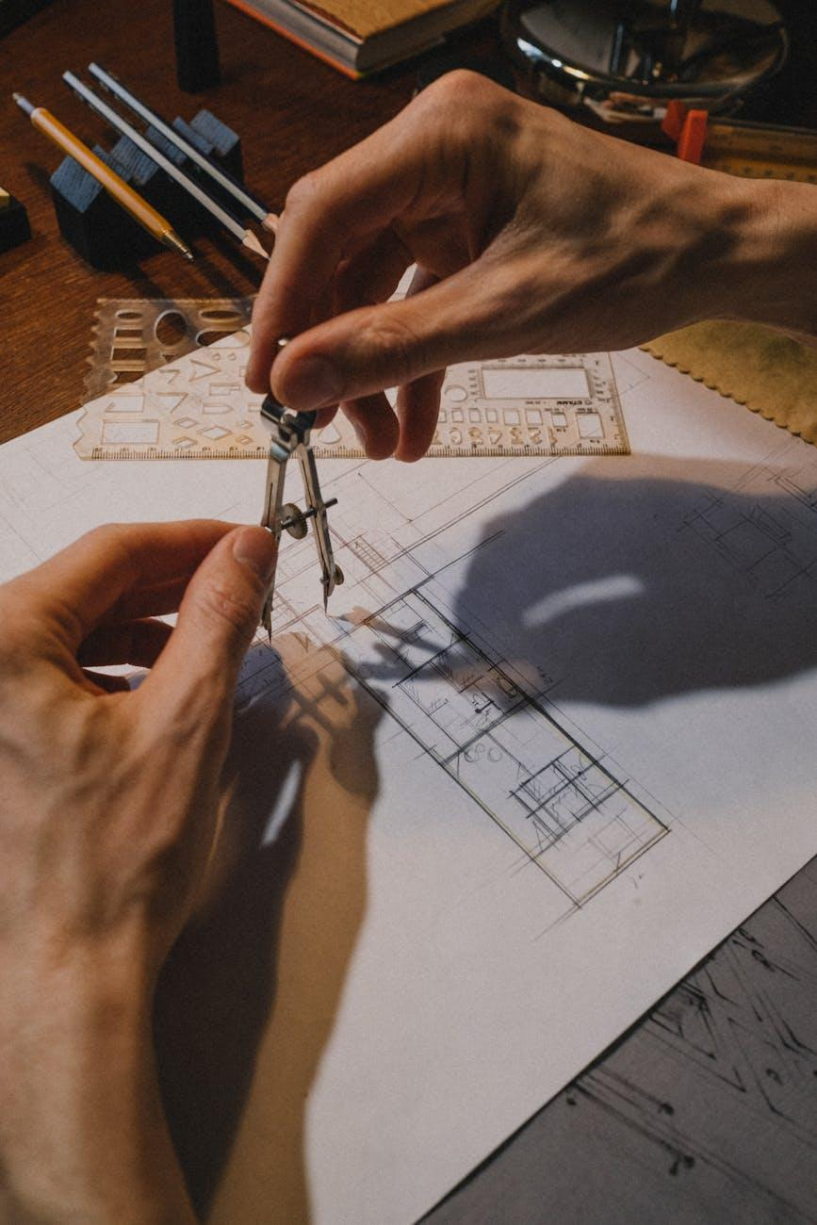

Fig.3 (Ron Lach on [Pexels](https://www.pexels.com/photo/9617896/), 2025) Performing quality checks ensures professional standards are maintained before client presentation

Making a habit of reviewing your work helps you meet professional standards.

**Starter Checklist:**

* Are measurements accurate and to scale?
* Have you addressed all client requirements?
* Are material selections clearly identified?
* Have you proofread all text?
* Are drawings properly labeled?

**Try this to build good habits:** Before submitting any design work, take time to review it against your quality checklist. This will become second nature as your career advances.

## Equipping You for HNC Success

These organizational systems form the foundation for advanced project management in your HNC studies, giving you the tools to handle complex design challenges with professional confidence.